Questions:

1. Alter the table STUDENT with following structure.

|  |  |  |
| --- | --- | --- |
| # | Column | Constraints |
| Name |
| 1 | RegNo | PRIMARY |
| KEY |
| 2 | MobileNo | NOT NULL |

1. Alter the table name FACULTY with following structure. The DeptNo in this table refers the DeptNo in the DEPARTMENT table.

|  |  |  |  |
| --- | --- | --- | --- |
|  | Column |  | Constraints |
| # | Name |  |  |
|  | FacNo |  | PRIMARY |
| 1 |  | KEY |
|  | Gender |  | CHECK |
| 2 |  | ‘M’ or ‘F’ |
| 3) | After the FACULTY table is successfully created, test if you can add a constraint | | |
| FOREIGN KEY to the DeptNo of this table. | | | |
| 4) | Alter the table name DEPARTMENT with following structure. | | |
|  | Column |  | Constraint |
| # | Name |  |  |
|  | DeptNo |  | PRIMARY |
| 1 |  | KEY |
| 5) | Alter the table name COURSE with following structure. | | |
|  | Column |  | Constraint |
| # | Name |  |  |
|  | CourseNo |  | PRIMARY |
| 1 |  | KEY |
| 2 | SemNo |  | 1 to 6 |

1)

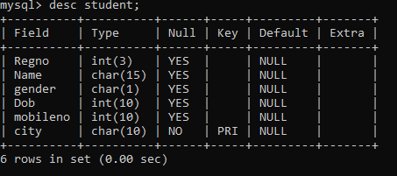

2)

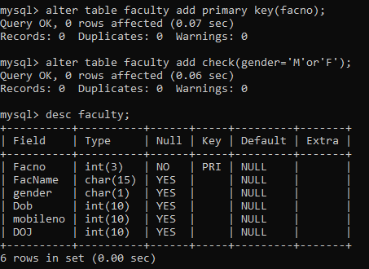

4)

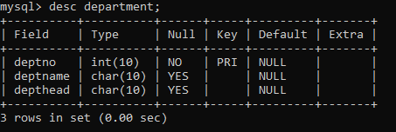

5)

